CSD 330 – Security Analytics

Homework 1

Part 1

  - 1. (Internet is allowed for finding the system and its documentation) Find a free and reputable intrusion detection system available on the Internet, open source if possible. Explain in no more than a page, how it works. Also provide the name and URL of the system you found.

Answer:
  - OpenWIPS-ng
  - http://openwips-ng.org/
  - OpenWIPS-ng is a free open-source NIDS dedicated to wireless networks–WIPS stands for wireless intrusion prevention system. This tool was developed by the same team who developed the well-known network intrusion tool Aircrack-ng.
  - You can use OpenWIPS-ng either as a WiFi packet sniffer or for intrusion detection. OpenWIPS-ng works exclusively on Linux systems and comes with three major components:
- A sensor to collect data and send out commands.
- A server that contains the analysis engine.
- An interface to display the events and alerts.
  - Most of the processing runs on the server since most of the plugins are running there, and the packets are reassembled there as well. The communication is encrypted by default and is handled by two types of channels: command and data.
  - This NIDS does have some limitations. Every installation includes only one sensor, and each sensor contains small CPUs. In addition, the sensors do not always detect the same traffic.
  - The following diagram illustrates the architecture of OpenWIPS-ng project:
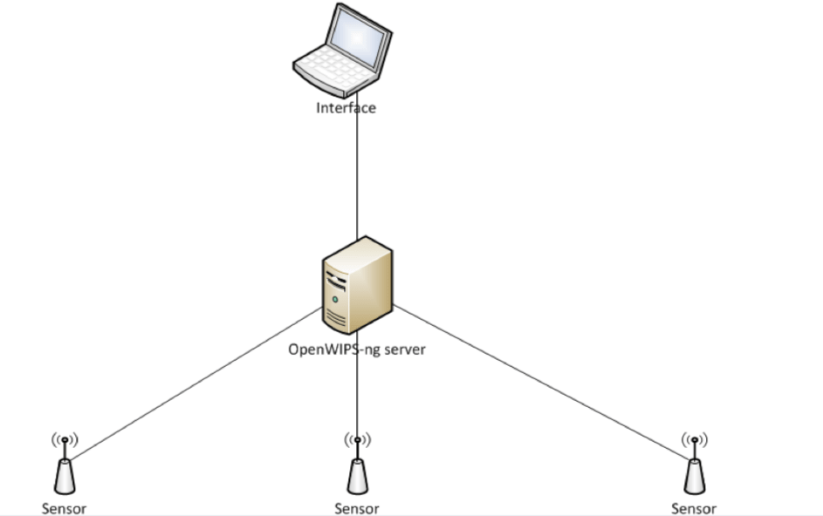
2. Is it possible to develop a program P that can analyze a piece of software to determine if it is a virus? Note that we are interested in exact methods, i.e., P should say yes only when the input program is a virus and no in all other cases.

Answer:
NO
Such a program cannot be developed, as even if we train is so perfectly that it detects all viruses accurately, there are always day zero attacks and metamorphic viruses that cannot be predicted.

3. Suggest and explain three methods for preventing intrusions in a computer that needs to remain connected to the Internet at all times.

Answer:
  - For computers that are connected to the Internet (especially with an "always on" connection such as cable or DSL), the users are at risk of intrusion by hackers or infection from a virus or spyware. This can happen without their knowledge. They can be browsing, logging on and off various web sites, etc., and be compromised. However, we can protect ourselves from this type of intrusion by following a few simple steps:
  - A firewall
  - A firewall is your first line of defence against anyone hacking into your computer. There are many software versions available if you don't want to use a router.
This software lets you set individual Internet access capabilities for individual programs, allows for automatic program configuration, and puts your computer into stealth mode, which makes your computer invisible to anyone else on the Internet. It also blocks intrusion to anyone trying to hack into your system automatically.
  - Using Routers
  - If you don't already have one, you should get yourself a router. This is important even if you only use one computer. This is a type of hardware firewall, which is the best kind. It will protect any personal information you have stored on your computer and will keep it safe. It will also protect your computer from being infected with various viruses.
Because hackers try to gain access to your computer by doing what's called "port scanning", a router can completely block the scans or at least slow a hacker's progress down. Most hackers want to work fast and won't waste a lot of time trying to get around a single router. Instead, they'll move on to someone else who doesn't have a computer that's well protected and that can be hacked.
  - Antivirus protection program
  - An antivirus protection program will scan your computer for viruses and then will quarantine them or will delete them if it can. It will give you the choice, oftentimes, as to whether to delete or quarantine. There are many good antivirus programs available. Many ISPs also provide their own antivirus programs.
Once an antivirus program is downloaded and installed, it will run in the background to make sure that your computer is always protected. Most antivirus programs will update hourly to daily. You can set them so that they will update automatically and therefore keep your computer protected with new definitions all the time. If set up correctly, your computer will have maximum protection from new virus intrusions.
Being armed with the proper virus protection is the best thing you can do for your computer to keep it running smoothly and to avoid unwanted intrusion.

4. Which of our seven security goals cannot be satisfied using cryptographic methods alone?
Justify your answers in each case.

  - The seven security goals are:
- Confidentiality – ADDRESSED
  - The sender can encrypt a message using a cryptographic and the message is decrypted using a key too.
- Authenticity – ADDRESSED
  - Digital signatures can help us prove identity. Eg: Kerberos
- Integrity – ADDRESSED
  - Hashing techniques help us check that the message has arrived in the intended form.
- Availability – NOT ADDRESSED
  - We cannot ensure availability using cryptographic methods alone.
- Authorisation – ADDRESSED
  - Access control can be implemented using cryptographic methods.
- Accountability - NOT ADDRESSED
  - If something goes wrong, just using cryptographic methods, we cannot determine who is at fault.
- Non-Repudiation – ADDRESSED
  - Private key cryptography helps ensure this.

5. (Internet is allowed for reading the article) Read the article Huge number of sites imperilled by critical image-processing vulnerability, at arstechnica.com. Give a 100 word summary of this article in your own words and list at least two security lessons that you learned from the article.

  - ImageMagick suffers from a vulnerability that allows malformed images to force a Web server to execute code of an attacker's choosing. Websites that use ImageMagick and allow users to upload images are at risk of attacks that could completely compromise their security. Recent versions of ImageMagick don't properly filter the uploaded file names before passing them to the server processes such as HTTPS. The omission allows attackers to execute commands of their choosing, leading to a full remote command capability.
  - Security Lessons ->
  - This is why onion layering/compartmentalization and mitigation concepts are so important to security: perfect security is impossible to determine in adequately complex systems. You should never rely on other layers of your security not being breached and should always assume that unanticipated vectors may breach a given layer completely and design the other layers accordingly. Don't figure out how you'll stop a breach from ever happening: figure out how to mitigate the breach that will happen. With that said, the people who primarily need to be concerned about this are those who take user submitted content and process it with ImageMagick. Of course, due to where ImageMagick is generally used (services with many users) it is potentially more severe from other standpoints, for those services using it.

6. Compute the remainder when your SNU ID is divided by 5. Let remainder 0 denote Monday, 1 denote Tuesday and so on. Check out the vulnerabilities released on the National Vulnerability Database on the last three days represented by your remainder. So for example, if 4 is the remainder, then you would check out the vulnerabilities released on the last 3 FRIDAYs. Use Sunday Jan 26 as the cutoff date for finding the last three days of interest. For each vulnerability found: give the number, short description, whether it was scored or not, score (if given), and whether it was marked critical or not. What did you learn from this exercise?

Answer:
  - My roll number is 1710110165.
  - Hence, I will be looking at MONDAYS
  - The days I have looked at are:
- 06 Jan 2020
- 13 Jan 2020
- 20 Jan 2020
  - The details are in the accompanying excel file for your referral.
  - I learnt a lot from this exercise. I learnt what constitutes a vulnerability, what vulnerabilities are more critical than others and also more than ever, I understood the importance of intrusion detection systems and internet security as I was overwhelmed by the number of vulnerabilities detected in a single day!

